**DEVOPS**

DAY 3 Task

**Git installation**

1. sudo apt update

2. sudo apt install git

3. git --version

4. git config --global user.name "Your Name"

5. git config --global user.email "your.email@example.com"

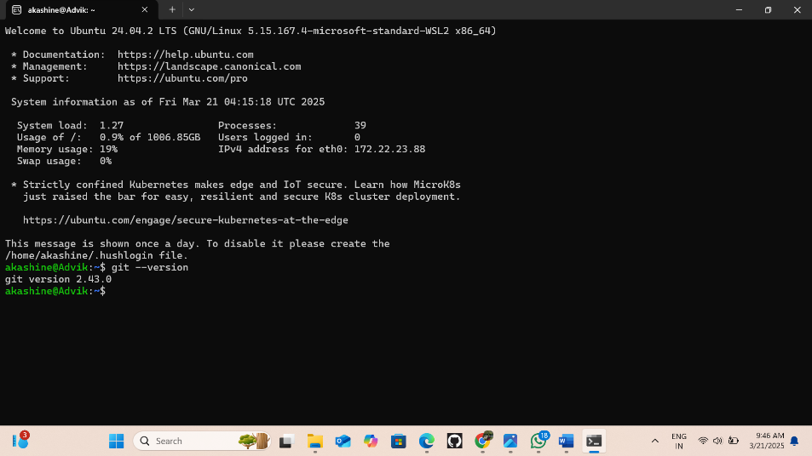

**JDK installation**

1. sudo apt update

2. sudo apt upgrade -y

3. sudo apt install default-jdk -y

4. java -version

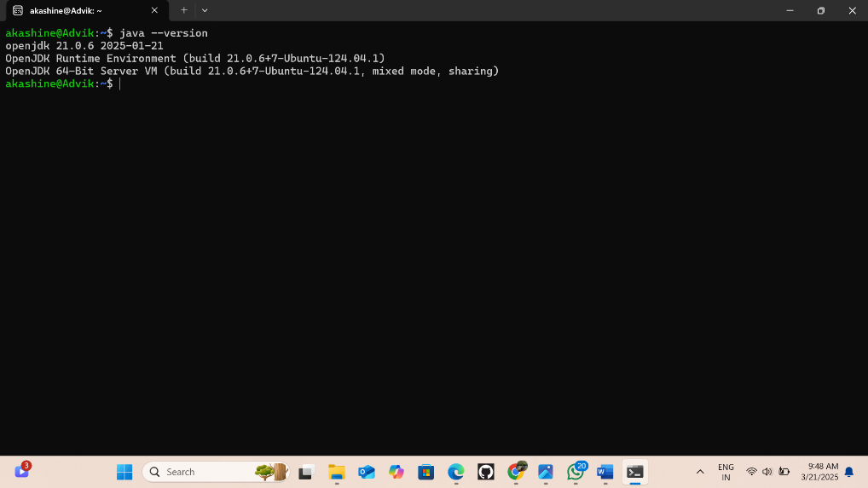

**Maven installation**

1. sudo apt install maven -y

2. mvn -version

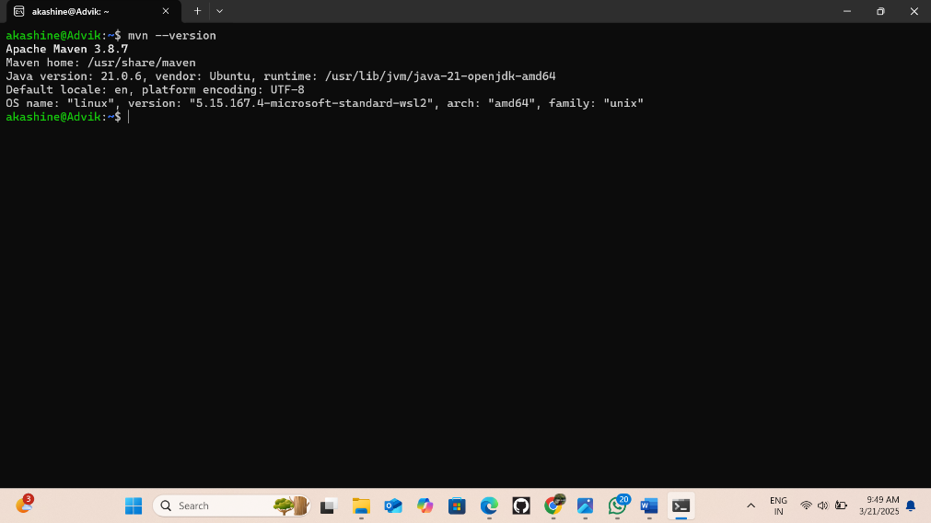

**Jenkins installation**

1. sudo wget -O /usr/share/keyrings/jenkins-keyring.asc \ https://pkg.jenkins.io/debian-stable/jenkins.io-2023.keyecho "deb [signed-by=/usr/share/keyrings/jenkins-keyring.asc]" \ https://pkg.jenkins.io/debian-table binary/ | sudo tee \ /etc/apt/sources.list.d/jenkins.list > /dev/nullsudo apt-get updatesudo apt-get install jenkins

2. sudo service Jenkins restart

3. sudo service Jenkins status

4. sudo cat /var/lib/jenkins/secrets/initialAdminPassword

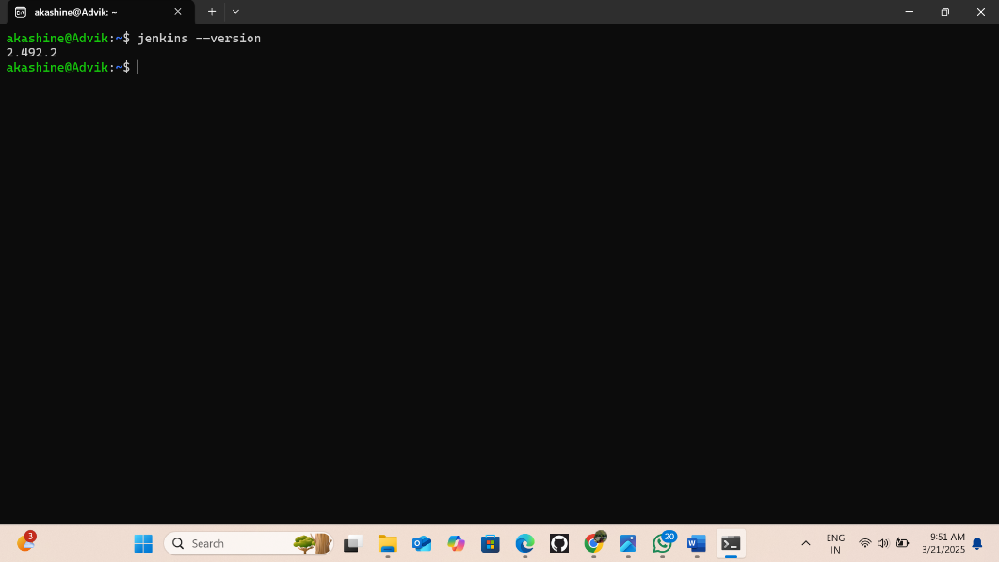

**Docker installation**

1. sudo apt install docker-compose -y

2. sudo service docker restart

3. sudo service docker status

4. sudo usermod -aG docker $USER

5. docker images

6. docker ps

7. sudo chmod 666 /var/run/docker.sock

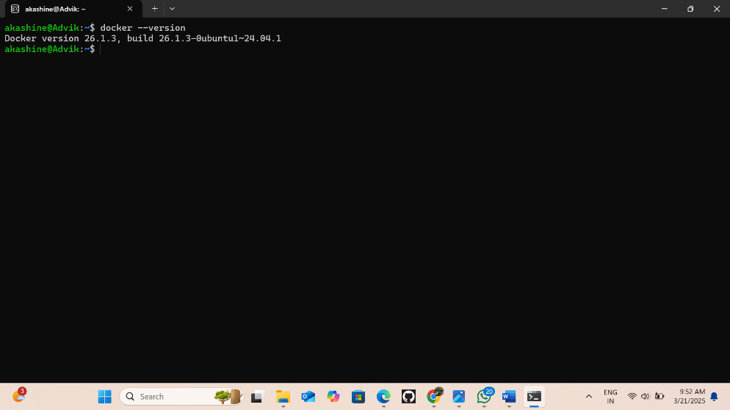

**Kubernetes installation**

1. Go to https://kubernetes.io/docs/tasks/tools/install-kubectl-linux/

2. curl -LO https://dl.k8s.io/release/v1.32.0/bin/linux/amd64/kubectl

3. sudo install -o root -g root -m 0755 kubectl /usr/local/bin/kubectl

4. chmod +x kubectl

mkdir -p ~/.local/bin

mv ./kubectl ~/.local/bin/kubectl

5. kubectl version --client

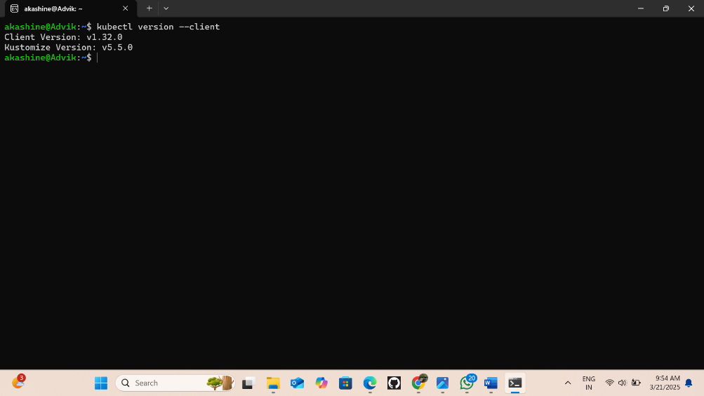

**Minikube installation**

1. Go to https://minikube.sigs.k8s.io/docs/start/?arch=%2Fwindows%2Fx86-64%2Fstable%2F.exe+download

2. curl -LO https://github.com/kubernetes/minikube/releases/latest/download/minikube-linux-amd64

3. sudo install minikube-linux-amd64 /usr/local/bin/minikube && rm minikube-linux-amd64

4. minikube start

5. minikube status

6. kubectl get pod

7. kubeclt get deploy

8. kubectl get replica or rs or replicaaset

9. kubectl get pod -o wide

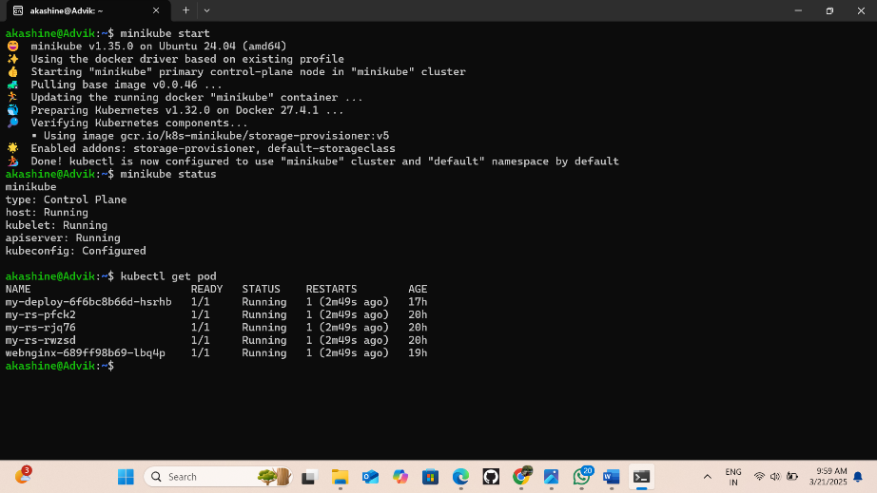

**Docker compose**

1. sudo apt install docker-compose -y

2. sudo nano docker-compose.yml

{

version: '3'

services:

web:

image: nginx:latest

ports:

- "80:80"

db:

image: mysql:latest

environment:

MYSQL_ROOT_PASSWORD: secret

}

3. docker-compose up -d

4. docker-compose images

5. docker-compose ps

6. sudo docker exec -it Akashine_db_1 bash

7. mysql -u root -p

